**TEST BENCH & TRAINING DATA**

Figure 1 shows the experimental setup used in this work. A steel cantilever beam structure of 759 x 50.66 x 4.19 mm is used for the experiments and a single Integral Electronics Piezoelectric (IEPE) accelerometer (PCB Piezotronics model J352C33) is placed near the edge of the beam structure. This accelerometer has a sensitivity of 100 mV/g with a frequency measurement range from 0.5 to 9k Hz. Using a 24-bit NI-9234 IEPE signal conditioner developed by National Instruments, the sensor data is digitized. The beam is excited by an electromagnetic shaker (LDS model V203R) that has a useful frequency range of 5-13000 Hz and a peak sinusoidal force of 17.8 N, itself powered by a power amplifier (LDS model PA25E-CE). A load cell with a range of 0-45 N (Transducer Techniques model MLP-10) is installed between the structure of the shaker and the beam. To acquire the load-cell data, a 24-bit bridge input signal conditioner (National Instruments NI-9237) is used. The experiment is controlled by custom code written in the LabVIEW environment.

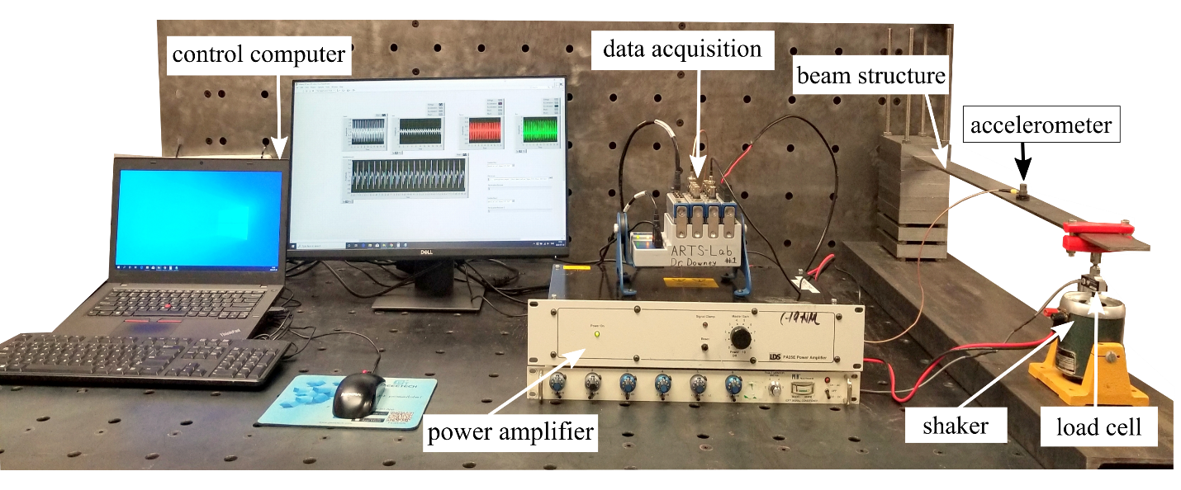

Figure 1: A cantilever beam experimental setup with the main components and set up for data acquisition.

For a composite sinusoidal input from the shaker, Figure 2 reports the measured acceleration response of the structure. The composite signal in this work consists of frequencies of 100, 120, and 150 Hz. At the *t*=0 s point, a 50% nonstationary is present as two sine wave signals are added together. The first half of the signal is paired with frequencies of 100 and 120 Hz and the other half with frequencies of 100, 120, and 150 Hz. As determined by a 50% rise in the standard deviation of the signal, a 50% nonstationary event is added at 0 s. For achieving an input signal of 0.25 V is used before *t=*0 while a signal of 0.375 V is used after *t=*0.

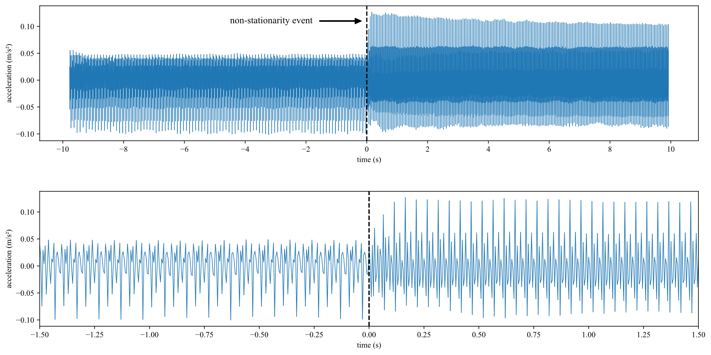

Figure 2: Experimental data showing the: (top) full dataset that the models were trained on, and; (bottom) a close-up within +/- 1 s of the non-stationarity event. Note that data is adjusted so that the non-stationarity event occurs at 0 s.